28.67: The contributions from the straight segments is zero since 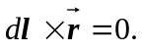 The magnetic field from the curved wire is just one quarter of a full loop:
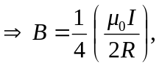
and is out of the page.

